EW0305 Hess Deep
Scripts for Copying and Processing Seisnet MCS files
Steffen Saustrup July '03

EW0305 was the first cruise to use the new .tcl scripts and accompanying sioseis/csh scripts, developed by Ethan Gold and Paul Henkart, to reformat, copy, and process "seisnet" MCS files in real-time.

Seisnet Files

Seisnet files are MCS shotfile data written in "seisnet" format (pseudo-SEGD) to /data, a RAID filesystem of about a terabyte on host heezen. Each seisnet file contains exactly one shot record, and is written in real-time using a naming convention that includes FFID (SEGD file number, as opposed to shot number) and a time stamp (strange units, something like "seconds since 1/1/1970"). For instance, seisnet file "FFID_248%1058593648" contains a single shot record, corresponding to one SEGD file on a 3490 tape, with an FFID of 248 and time stamp of 1058593648. Note that this time stamp is neither the time given to the UI script nor the time listed in the trace headers. Also note that FFID will not be unique during the course of a cruise, but that the time stamp will be unique. For EW0305 (240 channel, 12 seconds, 4 ms), each seisnet file was ~2.9 Mbytes.

As seisnet filenames are somewhat cryptic, you can use the "seisinfo" utility to list information about a single seisnet file or a list of files. Just type "seisinfo" and the pathname for one or more seisnet files in a terminal window. For instance, the command:

seisinfo /data/seisnet/0305/ FFID_248%1058593648

will return Line #, shotpoint, and jday/gmt information about this file. This is most useful when restarting the scripts after a stoppage or when limiting the files to input into a real-time stack job.

All seisnet files will be written to the same directory on /data. See the directory structure below.

In general, the seisnet files are a direct image of what's being written to 3490 tape; if data are being recorded to 3490 they're also being written to /data in seisnet format. However, during EW0305 we did have one instance when the seisnet computer crashed and data were written to tape but not to disk. Should this occur, the only clues to watchstanders will be that the RAID drive (behind watchstanders at knee level) will not blink after every shot, and that the seisnet screen (in the right hand corner of the watchstander station) will not update with an image of each new shot record. This is easy to miss, since the shot records look very similar. Should seisnet fail, alert the sysadmin and then later recover the shots from 3490 tape.

About the Scripts

The seisnet scripts run on heezen, write to disk on heezen, write to tape on heezen, and plot to the Atlantek on heezen. The actual script names are somewhat cumbersome, so I've included them in the path for user sioseis and I've aliased them in the .cshrc file as simply "seis2disk", "seis2tape", "tape2tape", and "seis2stack".

The 4 scripts are:

seis2disk – Reads seisnet, writes as SEGY on disk.
seis2tape – Reads seisnet, writes as SEGY on tape.
seis2stack – Reads seisnet, performs a simple "real-time" stack, writes an SEG-Y disk
file, and writes an output plotfile. This script is generally accompanied by
running the sioseis program "atlantek", which plots a sioseis plotfile as it is being
generated.
tape2tape – Reads SEGD 3490, writes SEGY on tape.

Each script consists of a user interface (UI) written in tcl, and an accompanying sioseis cshell script which is called by the UI. The sioseis script actually does the work, the UI manages input file lists, tape drives, etc. Users may choose to use the default sioseis scripts, which are centrally located, or may copy these scripts and edit them to perform customized functions. Users maintain "config" files to save UI parameter sets.

Any user tape devices (DAT or other) for SEGY output should be mounted on heezen and given an "nrst" link such that /dev/nrst# points to /dev/rmt/#bn. This # then becomes the "drive number" called by the UI.

You must run a copy of the script for each process. If writing to more than one tape device, run a copy of seis2tape for each tape device. Each script must be run in a different working directory so as not to corrupt the sioseis temporary files. During EW0305 we concurrently ran a seis2disk script, 3 seis2tape scripts (DLT and 2 DAT copies), and a seis2stack script – for a total of 5 scripts running on heezen. The CPU was able to keep up easily.

The UI scripts and their associated sioseis scripts are all located in /data/sioUI. For each script I have created a symbolic link which points to a .tcl script, which in turn calls a sioseis script. The UI manages the sioseis script, which does the actual work. They are:

my link actual UI script sioseis script
seis2disk => sioUI-seis2disk.tcl seis2disk_sioseis.csh
seis2tape => sioUI-seis2tape.tcl seis2tape_sioseis.csh
tape2tape => sioUI-tape2tape.tcl tape2tape_sioseis.csh
seis2stack => sioUI-seis2stack.tcl seis2stack_sioseis.csh

For EW0305, all scripts were run via a telnet session to heezen from one of the UTIG machines and using the $DISPLAY environment variable. If watchstanders are running the scripts it may be more convenient to run directly on heezen, located behind the watchstanders. In either case, login to heezen as user "sioseis". The UI scripts and the default sioseis scripts are not to be altered or customized by users. Any customization should be done by copying the default sioseis scripts to a working directory on /data and editing this copy.

Customizing the Scripts

To customize the scripts, some knowledge of sioseis is necessary. First, login as user "sioseis" (pw is siosieis) to heezen and create the proper working directory as described below. Copy the desired sioseis script (whatever_sioseis.csh) to this working directory and make changes to your copy. You may add, remove, or edit sioseis processes as you wish. Some of the scripts include writing a "circular" SEGY file of every nth shot to disk, this is to be used for real-time data qc. The seis2stack script is the one likely to require user customization. Whatever changes are made, this new sioseis script will then be referenced in the UI.

Script Parameters

The seis2disk UI window looks like this:

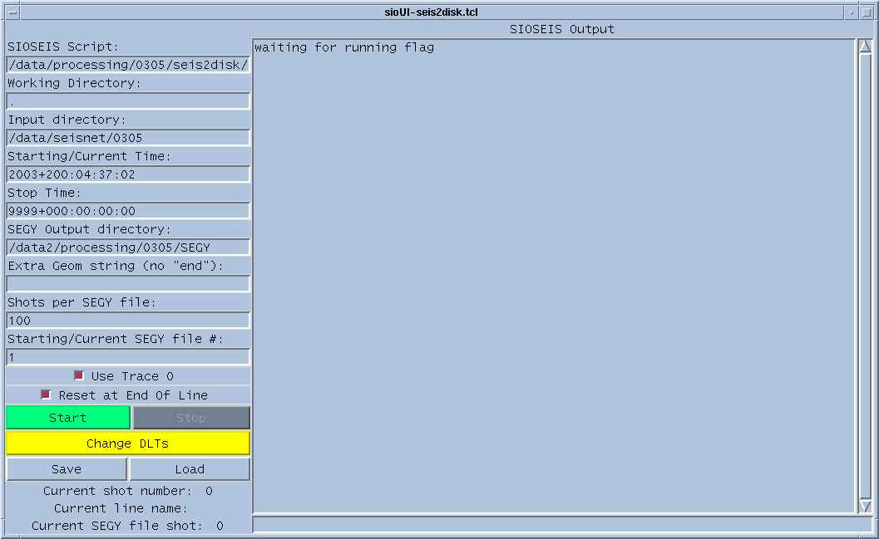

The parameters are:
-SIOSEIS script – defaults to the basic script in /data/sioUI, otherwise give the
pathname of a customized sioseis script that you have created. In this
example, I'm using my own script (the full pathname is truncated).
-Working directory – directory from which to run the sioseis job. In general, use
"." if you've already cd'd to your working directory. Note that more than
one script using the same working directory will cause bad things to
happen.
-Input directory – location of seisnet files, in general /data/seisnet/cruise#.
-Starting/Current Time – year/jday/gmt of first seisnet file to process. While a
script is running, this time will automatically increment with the time of
the last file processed, greatly simplifying restarts.
-Stop Time – year/jday/gmt of last seisnet file to process. Generally use the
default, which is some time in the future (i.e. just keep going).
-SEGY Output directory – pathname in which to write SEGY files. Files will be
named "Lineno.#.segy", where Lineno is the line name taken from the
LDEO header and # is from the "SEGY File #" parameter described below.
-Extra Geom String – If desired, enter sioseis "geom" parameters here to write
geometry information (cdp #, source-receiver offset, etc) to the trace
headers. This requires knowledge of sioseis.
-Shots per SEGY File – Number of shots to write into a single output SEGY file.
The default is 10, for EW0305 I used 100.
-Files per Tape – Number of SEGY files to write to an output tape. Calculate a
maximum files based on media capacity and "Shots per Tape File". For
EW0305 I used 125 for DLT type 4 and 35 for DDS3.
-Starting/Current SEGY File # - This will be the file number used in the output
SEGY file name. Use "1" to start. This # will automatically increment
with each file written and will reset to 1 at the beginning of a line, so you
don't really have to fool with this parameter unless you're restarting after
a stoppage.

In addition, the following toggle buttons are found at the bottom of the script:

-Use Trace 0 – keys the writing of LDEO trace 0 to output disk/tape. In general,
toggle this on.
-Reset at End of Line – keys the closing of the current output SEGY file and the
writing of a new output file when a new line is reached. I find this helpful
for bookkeeping.
-Start – Starts the script using the current parameters (or restarts after a
stoppage).
-Stop – Uses the sioseis parameter "in" to halt a script. Wait for the output to
show that sioseis has ended, then you may change a tape or restart the
script at any time.
-Change DLT's – Rewinds and offlines the tape device. Make sure you hit
"Stop" first. This parameter only works in the seis2tape script.
-Save – Save the current parameters to a config file. Use this early and often,
especially after any stoppage.
-Load – Load the contents of a previously-saved config file as the current
parameter list.

Note that the current line #, shot #, and output SEGY file # will update at the bottom of the window as the script runs.

The seis2tape UI window looks like this:

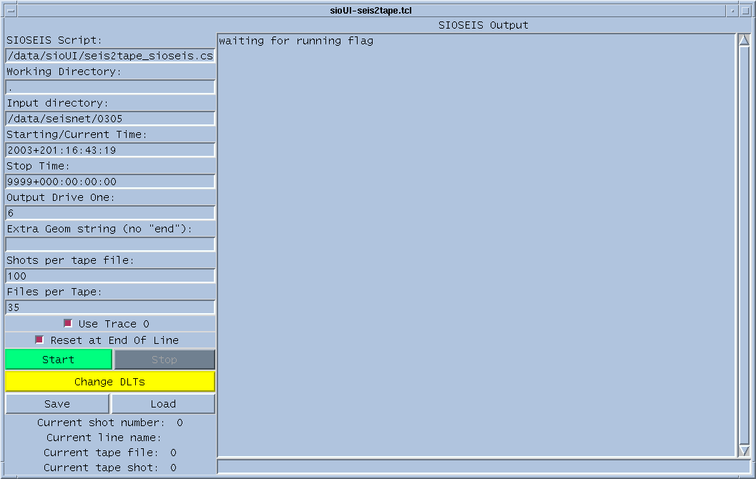

The parameters are the same as listed above, with the addition of the following:

-Output Drive 1 – The number of the output tape drive to write to. Sioseis will
attempt to write to drive /dev/nrst#, so make sure the symbolic link
mentioned above has been created. The "6" in this example causes SEGY
data to be written to /dev/nrst6, which has been aliased to /dev/rmt/6bn.

The seis2stack UI window looks like this:

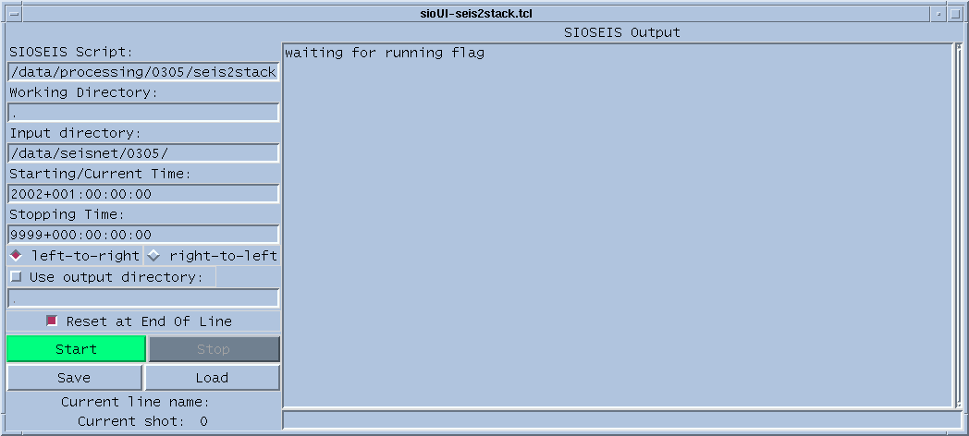

Parameters are the same, with the addition of:

left-to-right/right-to-left – toggle this button to determine the output plot direction
Plotfiles are written to the "stacked_plots" subdirectory of the working
directory.
Use output directory – toggle this on and give the pathname of a directory to send
stacked SEGY output somewhere other than the default, which is the
"stacked_lines" subdirectory of the working directory.

Running the Scripts

Note: The UI scripts handle saving and loading user-named "config" files. These config files save previously-entered parameters and are extremely useful, especially when restarting the scripts after a stoppage. Give the config file a name that identifies its calling script, such as "configstack" or "configrmt2". Saving config files often, especially after any stoppage, will make your life much simpler.

- Login as user "sioseis" on heezen. Open a new terminal window for each script. If running from a telnet or rlogin session, set the $DISPLAY variable to point back to your host.
- Start the UI script (simply type the name of the UI script or its alias). Using my aliases I simply type "seis2disk", for example. A UI window will appear.
- Either load a previously-saved config file with the "load" button or type the parameters in the spaces given. Limit the start/end shots using jday/gmt, or leave these tiimes wide open for continuous processing.
- Press "Start" and the sioseis script should kick off shortly. It may take a moment to build an input file list first. Output from the script will stream to the right-hand portion of the UI window.
- To stop or pause a job, press "Stop". You may then change a tape or make any changes you like. To resume the job press "Start". Stopping and starting jobs is fairly robust but may lead to shortened output files.

A logfile will be maintained in the working directory. The scripts seem to run trouble-free, but monitor the window output regularly to make sure that they haven't stopped.

Plotting the real-time stacked data to the Atlantek plotter is accomplished by cd'ing to the plot directory (stacked_plots subdirectory of the working directory) running this:

atlantek plotfilename

Line Change

No action is necessary for seis2disk or seis2tape during a line change, the scripts will simply wait for the next incoming seisnet file, will recognize a line change from the linename in the headers, and will automatically close the old SEGY files and open new ones. However, you may wish to save the config file at this time so that the starting/current time will be updated in the config file.

A line change is a good time to stop the seis2stack script, kill the "atlantek" process, and restart them both.

A line change is also a good time to copy SEGY data to your host machine, if desired.

Tape Change

When the user-specified number of files have been written to a tape, the UI script will pause and will prompt the user for a tape change. Press "Stop" and then press "Change DLT" to offline the tape -- or unload the tape manually. Insert a new tape, wait a moment for the new tape to load, and press "Start". That's it.

Restarting after a Stoppage

Once the scripts are running, they seem to be fairly robust and trouble-free. Pressing "Stop" and "Start" is very safe and copying will continue seamlessly. But should a script crash or or should a user kill a UI script and want to resart, here's what to do:

- Determine the last SEGY shot written to tape or disk (use lst or lsd on output
tapes/files or look in the logfile or read the screen ouput).
- Use "seisinfo" to determine the seisnet file corresponding to the last shot written to tape or disk. Copy the year/jday/gmt info from the seisinfo output.
- Make sure the output tapes are positioned correctly, or just change tapes if you're unsure.
- Restart the UI script, if necessary.
- Load your paramers from a configfile, if available. Otherwise type in your parameters manually.
- Update the Starting/Current Time to reflect the last shot written.
- If not using a new tape, reduce the "Files per Tape" by the number of files already
- written. If writing to disk, change the "Starting/Current SEGY File #" to reflect the next output SEGY disk file for the current line.
- Press "Start".

Directory Structure on Heezen

Please use the following convention for processing seisnet data on heezen:

disk directory subdir subdir description
/data/ RAID disk on heezen. About a terabyte.
sioUI/ All UI and sioseis scripts. Read-only.
seisnet / All seisnet files.
cruise#/ Seisnet files for your cruise. Read-only.
processing/ All user processing/copying of data.
cruise#/seis2disk/ | These are the working dirs for each of the
cruise#/seis2tape/ | scripts. CD to the proper dir before
cruise#/tape2tape/ | running the script, then enter "." as the
cruise#/seis2stack/ | working directory. If writing to more than
| one output tape, create a subdirectory as a | working dir for each device, e.g. | seis2tape/0305/rmt2 for writing to device | rmt2 on cruise EW0305.

/data2/ 100 Gbyte disk on heezen. General use.
processing/cruise# | Working dirs or output from scripts. | We've used /data2/processing/0305/SEGY | for the SEGY output from seis2disk. Be | careful of filling up this disk.

